# Storage File Share

## Demo: Create a File Share

1. Open your storage account and click on the FILE SHARES tile.

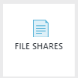

1. Click the **+ File Share** button.

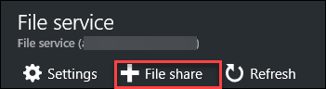

1. Name the Share **filesdemo** and set the Quota to **5120**.

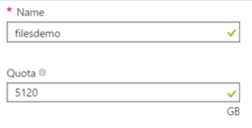

1. Once the Share is created Click the **Connect** button on the File Shares Blade

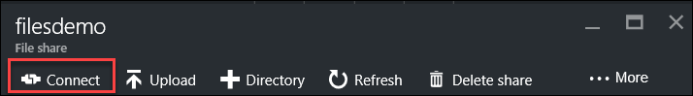

1. The Azure portal will then provide you with a string to use for mapping a drive.

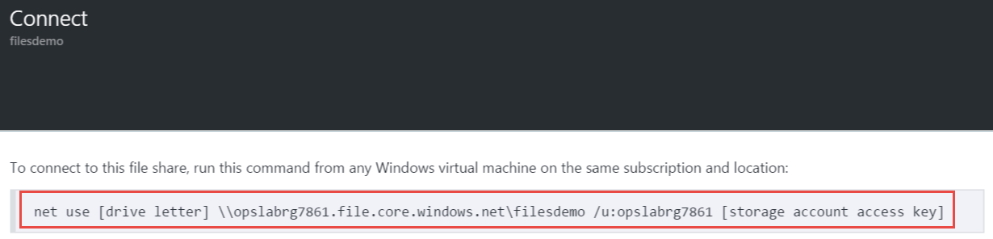

1. Copy the text of the net use command. Then open Notepad and paste the text into the window.
2. Move back to the Storage Account Blade and click the **Access Keys** button.

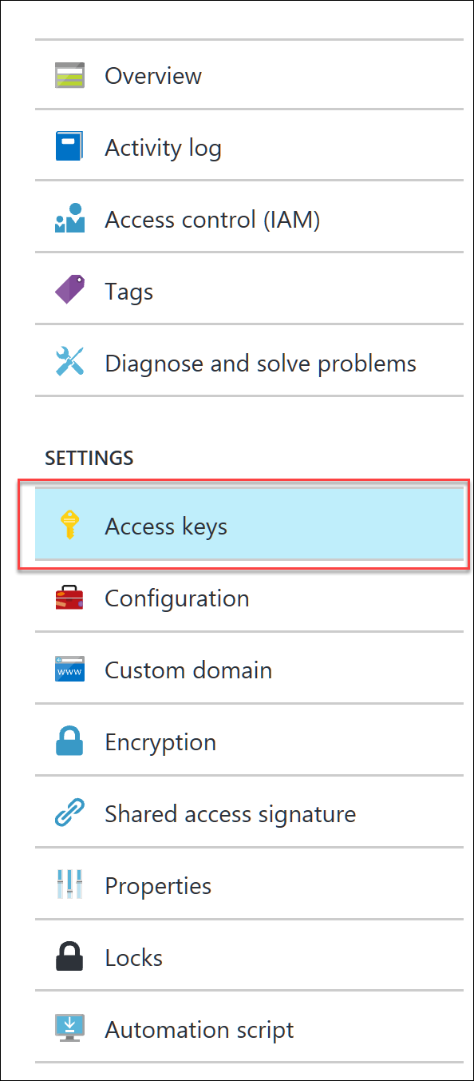

1. On the Access Keys Blade Press the click to copy button.

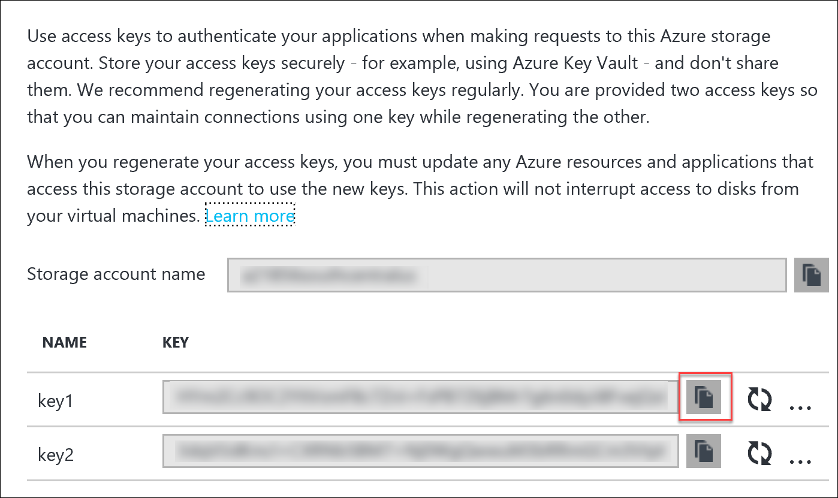

1. Move back to Notepad and replace the **[storage account access key]** with the key that you copied
2. Then replace the **[drive letter]** with the letter **O:**



1. Save the file as **netuse.txt** on your Desktop.
2. Browse back to your Storage Account and click on Files and then click your **filesdemo** share.

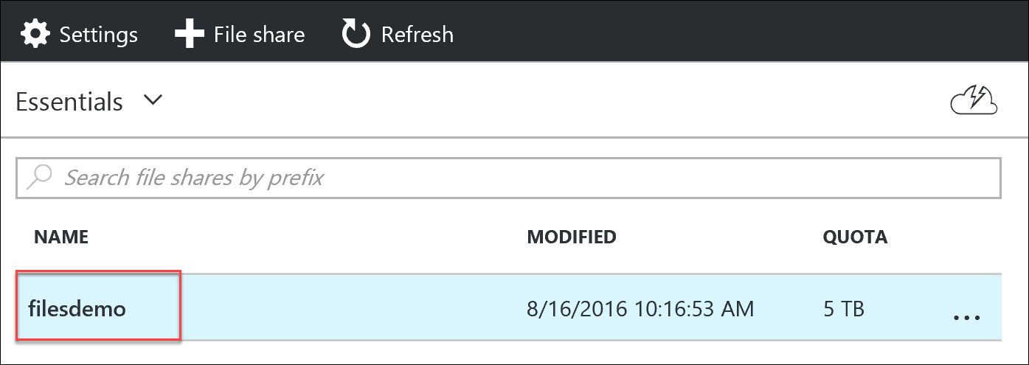

1. On the Upload files blade click the **blue folder**, navigate to your desktop and locate the any notepad file netuse.txt file. Once the file has been selected click **Upload**.

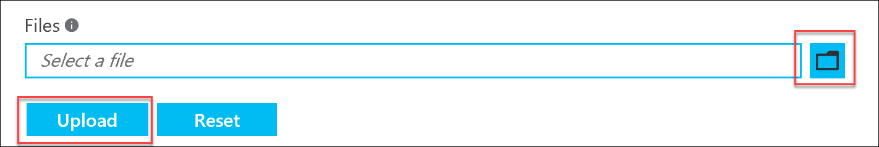

1. After the upload completes. show the file now found in the share.
2. Open a Command prompt and paste the net use command into the window.

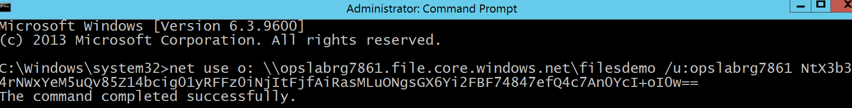

1. Open File Explorer and show how the Azure File Share has been mapped to drive O:\ and that the netuse.txt file is in the share.

